**Week 7 Solutions**

**React**

**10. ReactJS-HOL** .

Create a React Application named “officespacerentalapp” which uses React JSX to create elements, attributes and renders DOM to display the page.

The code and the folder structure is attached in the **Week 7/** **officespacerentalapp** folder

**Output :-**

**Chrome –** [**http://localhost:3000/**](http://localhost:3000/)

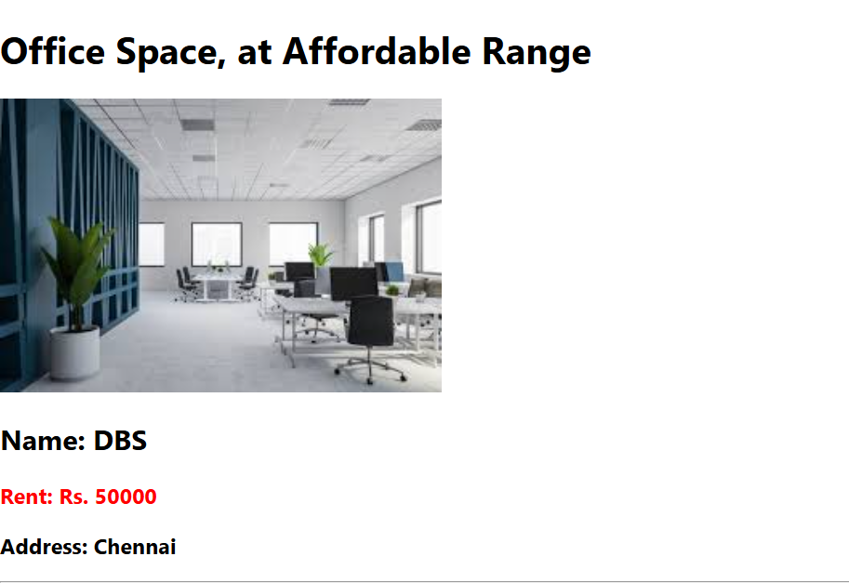

**The hands on file and folder is attached along with it**